The Annual Quality Assurance Report (AQAR) of the IQAC

(2013-2014)

All NAAC accredited institutions will submit an annual self-reviewed progress report to NAAC, through its IQAC. The report is to detail the tangible results achieved in key areas, specifically identified by the institutional IQAC at the beginning of the academic year. The AQAR will detail the results of the perspective plan worked out by the IQAC. (Note: The AQAR period would be the Academic Year. For example, July 1, 2012 to June 30, 2013)

Part – A
1. Details of the Institution
K.R.P.College of Education
1.1 Name of the Institution
Pachampalayam
1.2 Address Line 1
Sankari West
Address Line 2
Namakkal District
City/Town
Tamilnadu
State
637303
Pin Code
krpinstitutions@gmail.com
Institution e-mail address
04283 - 254277

Contact Nos.
Dr.D.Ramesha Naik
Name of the Head of the Institution:
04283 - 254277
Tel. No. with STD Code:
09449201051
Mobile:
Mr.C.Shankar
Name of the IQAC Co-ordinator:
09952366103
Mobile:
Krpiqac2012@gmail.com
IQAC e-mail address:

1.3 NAAC Track ID (For ex. MHCOGN 18879) 12353
www.krpinstitution.org
1.4 Website address:
www.krpinstitution.org/AQAR2013-14
-
Web-link of the AQAR:
For ex. http://www.ladykeanecollege.edu.in/AQAR2013-14.doc

1.5 Accreditation Details
Sl. No. | Cycle | Grade | CGPA | Year of Accreditation | Validity Period
1 | 1st Cycle | B | 2.75 | 2013 | 5 Years
2 | 2nd Cycle | - | - | - | -
3 | 3rd Cycle | - | - | - | -
4 | 4th Cycle | - | - | - | -

1.6 Date of Establishment of IQAC : DD/MM/YYYY
13.01.2012

2013-14
1.7 AQAR for the year (for example 2010-11)

1.8 Details of the previous year’s AQAR submitted to NAAC after the latest Assessment and Accreditation by NAAC ((for example AQAR 2010-11submitted to NAAC on 12-10-2011)
- AQAR 2012-2013 submitted to NAAC on 13/03/2014
- AQAR__________________NIL ________________________ (DD/MM/YYYY)
- AQAR__________________ NIL_______________________ (DD/MM/YYYY)
- AQAR__________________NIL _______________________ (DD/MM/YYYY)
1.9 Institutional Status
----
--
-
--
University State Central Deemed Private
√

Affiliated College Yes No
Constituent College Yes No

Autonomous college of UGC Yes No

Regulatory Agency approved Institution Yes No
(eg. AICTE, BCI, MCI, PCI, NCI)
√

Type of Institution Co-education Men Women

√

Urban Rural Tribal

Financial Status Grant-in-aid UGC 2(f) UGC 12B

Grant-in-aid + Self Financing Totally Self-financing

√

1.10 Type of Faculty/Programme

Arts Science Commerce Law PEI (Phys Edu)

TEI (Edu) Engineering Health Science Management
√

NIL
Others (Specify)
TAMILNADU TEACHERS EDUCATION UNIVERSITY, CHENNAI-05
1.11 Name of the Affiliating University (for the Colleges)

1.12 Special status conferred by Central/ State Government-- UGC/CSIR/DST/DBT/ICMR etc
Nil
Autonomy by State/Central Govt. / University
-
University with Potential for Excellence UGC-CPE
-
-
-
DST Star Scheme UGC-CE
-
-
UGC-Special Assistance Programme DST-FIST
-
-
UGC-Innovative PG programmes Any other (Specify)
-
UGC-COP Programmes

2. IQAC Composition and Activities
3
2.1 No. of Teachers
2
2.2 No. of Administrative/Technical staff
NIL
2.3 No. of students
2.4 No. of Management representatives
1
1
2.5 No. of Alumni
2.6 No. of any other stakeholder and
NIL
Community representatives
1
2.7 No. of Employers/ Industrialists
1
2.8 No. of other External Experts
2.9 Total No. of members
1
]’
loiouyr
9
2.10 No. of IQAC meetings held
1
2
2.11 No. of meetings with various stakeholders: No. Faculty
2
1
1
Non-Teaching Staff Students Alumni Others
---
√

2.12 Has IQAC received any funding from UGC during the year? Yes No
-
If yes, mention the amount
2.13 Seminars and Conferences (only quality related)
(i) No. of Seminars/Conferences/ Workshops/Symposia organized by the IQAC
1
-
1
-
-
Total Nos. International National State Institution Level
TEACHERS EDUCATION FEATURES – “TODAYS’ TRENDS, TOMORROW’S EXPECTATIONS”
(ii) Themes
2.14 Significant Activities and contributions made by IQAC
Institutional Project has been made and a National Seminar has been conducted.

2.15 Plan of Action by IQAC/Outcome
The plan of action chalked out by the IQAC in the beginning of the year towards quality
Enhancement and the outcome achieved by the end of the year *

Plan of Action | Achievements
Students Seminar with Power Point Presentation  Research Colloquium for M.Ed students | Implemented
* Attach the Academic Calendar of the year as Annexure-I
√

-
2.15 Whether the AQAR was placed in statutory body Yes No
√

-
-
Management Syndicate Any other body

Provide the details of the action taken
The AQAR was placed at the management committee and discussed.

Part – B
Criterion – I

1. Curricular Aspects

1.1 Details about Academic Programmes
Level of the Programme | Number of existing Programmes | Number of programmes added during the year | Number of self-financing programmes | Number of value added / Career Oriented programmes
PhD | - | - | - | -
PG | 1 | - | - | -
UG | 1 | - | - | -
PG Diploma | - | - | - | -
Advanced Diploma | - | - | - | -
Diploma | - | - | - | -
Certificate | - | - | - | -
Others | - | - | - | -
Total | 2 | - | - | -

Interdisciplinary | - | - | - | -
Innovative | - | - | - | -

1.2 (i) Flexibility of the Curriculum: CBCS/Core/Elective option / Open options
(ii) Pattern of programmes:
Pattern | Number of programmes
Semester | -
Trimester | -
Annual | 1

√

√

√

√

1.3 Feedback from stakeholders* Alumni Parents Employers Students
(On all aspects)

√

Mode of feedback : Online Manual Co-operating schools (for PEI)
*Please provide an analysis of the feedback in the Annexure-II

1.4 Whether there is any revision/update of regulation or syllabi, if yes, mention their salient aspects.
Yes, Updated as Per University regulations, and content improved.

1.5 Any new Department/Centre introduced during the year. If yes, give details.
No

Criterion – II
2. Teaching, Learning and Evaluation
2.1 Total No. of permanent faculty
Total | Asst. Professors | Associate Professors | Professors | Others
16 | 13 | 1 | 1 | 1(PRINCIPAL)
3
2.2 No. of permanent faculty with Ph.D.
2.3 No. of Faculty Positions Recruited (R) and Vacant (V) during the year
Asst. Professors |  | Associate Professors |  | Professors |  | Others |  | Total
R | V | R | V | R | V | R | V | R | V
3 | - | - | - | - | - | - | - | 3 | -
1
1
NIL
2.4 No. of Guest and Visiting faculty and Temporary faculty

2.5 Faculty participation in conferences and symposia:

No. of Faculty | International level | National level | State level
Attended Seminars/ Workshops | 3 | 15 | -
Presented papers | 3 | 15 | -
Resource Persons | - | - | -

2.6 Innovative processes adopted by the institution in Teaching and Learning:
Power Point Presentations, Smart class, Field based Activities

200
2.7 Total No. of actual teaching days
during this academic year
2.8 Examination/ Evaluation Reforms initiated by
NIL
the Institution (for example: Open Book Examination, Bar Coding,
Double Valuation, Photocopy, Online Multiple Choice Questions)

NIL
-
2.9 No. of faculty members involved in curriculum
restructuring/revision/syllabus development
as member of Board of Study/Faculty/Curriculum Development workshop
94.15 %
2.10 Average percentage of attendance of students

2.11 Course/Programme wise distribution of pass percentage:

Title of the Programme | Total no. of students appeared | Division
Title of the Programme | Total no. of students appeared | Distinction % | I % | II % | III % | Pass %
B.Ed | 98 | 28 | 58 | 2 | - | 93.00
M.Ed | 34 | 0 | 16 | 12 | - | 85.29
- | - | - | - | - | - | -

2.12 How does IQAC Contribute/Monitor/Evaluate the Teaching & Learning processes:
IQAC Members, Visit, Monitor and Evaluate the teaching, learning process during teaching
Practice. The IQAC members guide the post graduate students, on their dissertation.
2.13 Initiatives undertaken towards faculty development
Faculty / Staff Development Programmes | Number of faculty  benefitted
Refresher courses | NIL
UGC – Faculty Improvement Programme | NIL
HRD programmes | NIL
Orientation programmes | NIL
Faculty exchange programme | NIL
Staff training conducted by the university | NIL
Staff training conducted by other institutions | NIL
Summer / Winter schools, Workshops, etc. | NIL
Others | NIL

2.14 Details of Administrative and Technical staff
Category | Number of Permanent  Employees | Number of Vacant  Positions | Number of permanent positions filled during the Year | Number of positions filled temporarily
Administrative Staff | 2 | NIL | NIL | NIL
Technical Staff | 3 | NIL | NIL | NIL

Criterion – III
3. Research, Consultancy and Extension
3.1 Initiatives of the IQAC in Sensitizing/Promoting Research Climate in the institution
Institutional Project Titled “New Technology and Instructional Usage of Teacher Trainees and Teacher Educators
”

3.2 Details regarding major projects
 | Completed | Ongoing | Sanctioned | Submitted
Number | - | - | - | -
Outlay in Rs. Lakhs | - | - | - | -

3.3 Details regarding minor projects
 | Completed | Ongoing | Sanctioned | Submitted
Number | - | - | - | -
Outlay in Rs. Lakhs | - | - | - | -

3.4 Details on research publications
 | International | National | Others
Peer Review Journals | - | 2 | -
Non-Peer Review Journals | - | - | -
e-Journals | - | - | -
Conference proceedings | - | - | -

3.5 Details on Impact factor of publications:
-
-
-
-
Range Average h-index Nos. in SCOPUS
3.6 Research funds sanctioned and received from various funding agencies, industry and other organisations
Nature of the Project | Duration  Year | Name of the  funding Agency | Total grant  sanctioned | Received
Major projects | - | - | - | -
Minor Projects | - | - | - | -
Interdisciplinary Projects | - | - | - | -
Industry sponsored | - | - | - | -
Projects sponsored by the University/ College | - | - | - | -
Students research projects  (other than compulsory by the University) | - | - | - | -
Any other(Specify) | - | - | - | -
Total | - | - | - | -
-

3.7 No. of books published i) With ISBN No. Chapters in Edited Books
1
-
-
ii) Without ISBN No.
3.8 No. of University Departments receiving funds from
UGC-SAP CAS DST-FIST
-
-
-
-
-
DPE DBT Scheme/funds
3.9 For colleges Autonomy CPE DBT Star Scheme
-
-
-
INSPIRE CE Any Other (specify)
-
-
-
NIL
3.10 Revenue generated through consultancy
Level | International | National | State | University | College
Number | - | 1 | - | - | -
Sponsoring agencies | - | - | - | - | -
3.11 No. of conferences
organized by the Institution
1
3.12 No. of faculty served as experts, chairpersons or resource persons
-
-
-
3.13 No. of collaborations International National Any other
-
3.14 No. of linkages created during this year
3.15 Total budget for research for current year in lakhs: NIL
-
-
From funding agency From Management of University/College
Total
-

3.16 No. of patents received this year
Type of Patent |  | Number
National | Applied | -
National | Granted | -
International | Applied | -
International | Granted | -
Commercialised | Applied | -
Commercialised | Granted | -

3.17 No. of research awards/ recognitions received by faculty and research fellows
Of the institute in the year
Total | International | National | State | University | Dist | College
- | - | - | - | - | - | -

3.18 No. of faculty from the Institution
1
who are Ph. D. Guides
and students registered under them
4

3.19 No. of Ph.D. awarded by faculty from the Institution
-

3.20 No. of Research scholars receiving the Fellowships (Newly enrolled + existing ones)
-
-
JRF SRF Project Fellows Any other
-
-

3.21 No. of students Participated in NSS events:
-
-
University level State level
National level International level
-
-

3.22 No. of students participated in NCC events:
-
-
University level State level
National level International level
-
-

3.23 No. of Awards won in NSS:
-
University level State level
-
National level International level
-
-

3.24 No. of Awards won in NCC:
University level State level
-
-
National level International level
-
-

3.25 No. of Extension activities organized:
-
3
University forum College forum
-
-
3
NCC NSS Any other

3.26 Major Activities during the year in the sphere of extension activities and Institutional Social Responsibility
- Eye and Dental Camp -1
- Dengue Fever and Smokeless Pongal - Students Rally-2

Criterion – IV
4. Infrastructure and Learning Resources
4.1 Details of increase in infrastructure facilities:
Facilities | Existing | Newly created | Source of Fund | Total
Campus area | 1.17 Acres | 0.88 Cents | - | 2.05 Acres
Class rooms | 6 | - | - | 6
Laboratories | 8 | - | - | 8
Seminar Halls | 2 | - | - | 2
No. of important equipments purchased (≥ 1-0 lakh) during the current year. | 487 | - | Fees Collection | 487
Value of the equipment purchased during the year (Rs. in Lakhs) | 4,79,924.00 | - | Fees Collection | 4,79,924.00
Others | - | - | - | -

4.2 Computerization of administration and library
Yes. Automation.

4.3 Library services:
 | Existing |  | Newly added |  | Total
 | No. | Value | No. | Value | No. | Value
Text Books | 7124 | 9,56,704.00 | 560 | 40,966.00 | 9100 | 9,79,189.00
Reference Books |  |  | 1410 | Donated Books
e-Books
Journals |  |  | 25 | 13,385.00 | 25
e-Journals
Digital Database
CD & Video
Others (specify)

4.4 Technology up gradation (overall)
 | Total Computers | Computer Labs | Internet | Browsing Centres | Computer Centres | Office | Depart-ments | Others
Existing | 21 | 16 | 3 | - | - | 2 | - | -
Added | 5 | - | - | - | - | - | - | 5
Total | 26 | 16 | 3 | - | - | 2 | - | 5

4.5 Computer, Internet access, training to teachers and students and any other programme for technology
upgradation (Networking, e-Governance etc.)
Net – Working

4.6 Amount spent on maintenance in lakhs :
Rs.118838.20
i) ICT
Rs.2,58, 480.00
ii) Campus Infrastructure and facilities
Rs.450.00
iii) Equipments
-
iv) Others

Rs.3,77,768.20
Total :

Criterion – V
5. Student Support and Progression
5.1 Contribution of IQAC in enhancing awareness about Student Support Services
NET/SET Coaching

5.2 Efforts made by the institution for tracking the progression
Arrangements of Resource Persons

5.3 (a) Total Number of students
UG | PG | Ph. D. | Others
100 | 35 | - | -

(b) No. of students outside the state
NIL
NIL
(c) No. of international students

Men Women
No | %
54 | 40
No | %
81 | 60
Last Year |  |  |  |  |  | This Year
General | SC | ST | OBC | Physically Challenged | Total | General | SC | ST | OBC | Physically Challenged | Total
1 | 89 | 4 | 41 | NIL | 135 | NIL | 79 | 9 | 47 | NIL | 135
Demand ratio -Nil Dropout % - Nil
5.4 Details of student support mechanism for coaching for competitive examinations (If any)
TRB / TET / SET / NET

135
No. of students beneficiaries

5.5 No. of students qualified in these examinations
-
-
-
-
NET SET/SLET GATE CAT
IAS/IPS etc State PSC UPSC Others
-
2
-
5

5.6 Details of student counselling and career guidance
Counselling given to needed students by experts through guest lecturers.

135
No. of students benefitted

5.7 Details of campus placement
On campus |  |  | Off Campus
Number of Organizations Visited | Number of Students Participated | Number of Students Placed | Number of Students Placed
4 | 66 | 12 | 10

5.8 Details of gender sensitization programmes
NIL

5.9 Students Activities
5.9.1 No. of students participated in Sports, Games and other events
-
-
-
State/ University level National level International level

No. of students participated in cultural events
-
-
-
State/ University level National level International level

5.9.2 No. of medals /awards won by students in Sports, Games and other events
-
-
-
Sports : State/ University level National level International level
-
-
-
Cultural: State/ University level National level International level

5.10 Scholarships and Financial Support
 | Number of  students | Amount
Financial support from institution | NIL | NIL
Financial support from state government SC/ST Scholarships(2013-2014) |  | (93 members ) Rs.47,44,820.00
Financial support from other sources | - | -
Number of students who received International/ National recognitions | - | -

5.11 Student organised / initiatives
-
-
-
Fairs : State/ University level National level International level
-
-
-
Exhibition: State/ University level National level International level
1
5.12 No. of social initiatives undertaken by the students

5.13 Major grievances of students (if any) redressed: ___NIL___________________________________

Criterion – VI
6. Governance, Leadership and Management
6.1 State the Vision and Mission of the institution
Annexure III Enclosed

6.2 Does the Institution have a management Information System
Yes

6.3 Quality improvement strategies adopted by the institution for each of the following:
6.3.1 Curriculum Development
As Instructed by the University.

6.3.2 Teaching and Learning
Conventional Teaching and Power Point Presentation.

6.3.3 Examination and Evaluation
Slip Test, Unit Test and Model Test.

6.3.4 Research and Development
Institutional Project was Carried out and implemented.

6.3.5 Library, ICT and physical infrastructure / instrumentation
e-library, Bar Coding and Automation implemented

6.3.6 Human Resource Management
Yes , there is an approved selection committee of the college. It selects the academic and non-academic staff. The selection of staff is approved by the university according to the existing norms fixed by UGC and NCTE.

6.3.7 Faculty and Staff recruitment
3 faculties has been Recruited by the selection committee this year.

6.3.8 Industry Interaction / Collaboration
-

6.3.9 Admission of Students
Admissions are made according to the guidelines as per university norms

Teaching | Yes, Available
Non teaching | Yes, Available
Students | Yes, Available

6.4 Welfare schemes for

Rs.6 Lacs.
6.5 Total corpus fund generated
√
-
6.6 Whether annual financial audit has been done Yes No

6.7 Whether Academic and Administrative Audit (AAA) has been done?
Audit Type | External |  | Internal
Audit Type | Yes/No | Agency | Yes/No | Authority
Academic | - | - | Yes | Head of the Institution
Administrative | Yes | Approved Auditor | Yes | Administrative Officer

6.8 Does the University/ Autonomous College declare results within 30 days?
-
√
For UG Programmes Yes No
-
√
For PG Programmes Yes No
6.9 What efforts are made by the University/ Autonomous College for Examination Reforms?
Under the purview of the University

6.10 What efforts are made by the University to promote autonomy in the affiliated/constituent colleges?
Under the jurisdiction of the University

6.11 Activities and support from the Alumni Association
Competitions are conducted for the students by the alumni Association

6.12 Activities and support from the Parent – Teacher Association
Suggestions are offered by the PTA. The PTA supports all the activities.

6.13 Development programmes for support staff
The staffs are encouraged to attend seminars, conferences and to present papers at various levels. Guest Lecturers are provided to the staff to improve the quality in the process of teaching and learning.

6.14 Initiatives taken by the institution to make the campus eco-friendly
Saplings are planted to keep the atmosphere eco-friendly.

Criterion – VII
7. Innovations and Best Practices
7.1 Innovations introduced during this academic year which have created a positive impact on the
Functioning of the institution. Give details.
Teaching through power point presentation and smart class using LED.

7.2 Provide the Action Taken Report (ATR) based on the plan of action decided upon at the
beginning of the year
Preparation of Power point presentation for one unit for all paper for both M.Ed and B.Ed

7.3 Give two Best Practices of the institution (please see the format in the NAAC Self-study Manuals)
- Peer Group Tutoring (Annexure IV-A Enclosed)
- Students Community Project (Annexure IV-B Enclosed)
III

*Provide the details in annexure IV-A, and IV-B )
7.4 Contribution to environmental awareness / protection
Sapling Trees in and around the campus.

7.5 Whether environmental audit was conducted? Yes No

√

7.6 Any other relevant information the institution wishes to add. (For example SWOT Analysis)
- The strength of the institution is the infrastructure facilities gifted by the management.
- The quality of the teacher education is maintained.
- The suggestion of NAAC committee has been considered for the extension of quality parameters in all areas. Earnest steps have been taken to rectify the problems.

8. Plans of institution for next year
1. In-service Training Programme - 1
2. Students Seminar - 1

Name:Mr. C.Shankar, Co-ordinator. Name: Dr.D.Rameshanaik, Principal.

Signature of the Coordinator, IQAC Signature of the Chairperson, IQAC

_______***_______

Annexure I
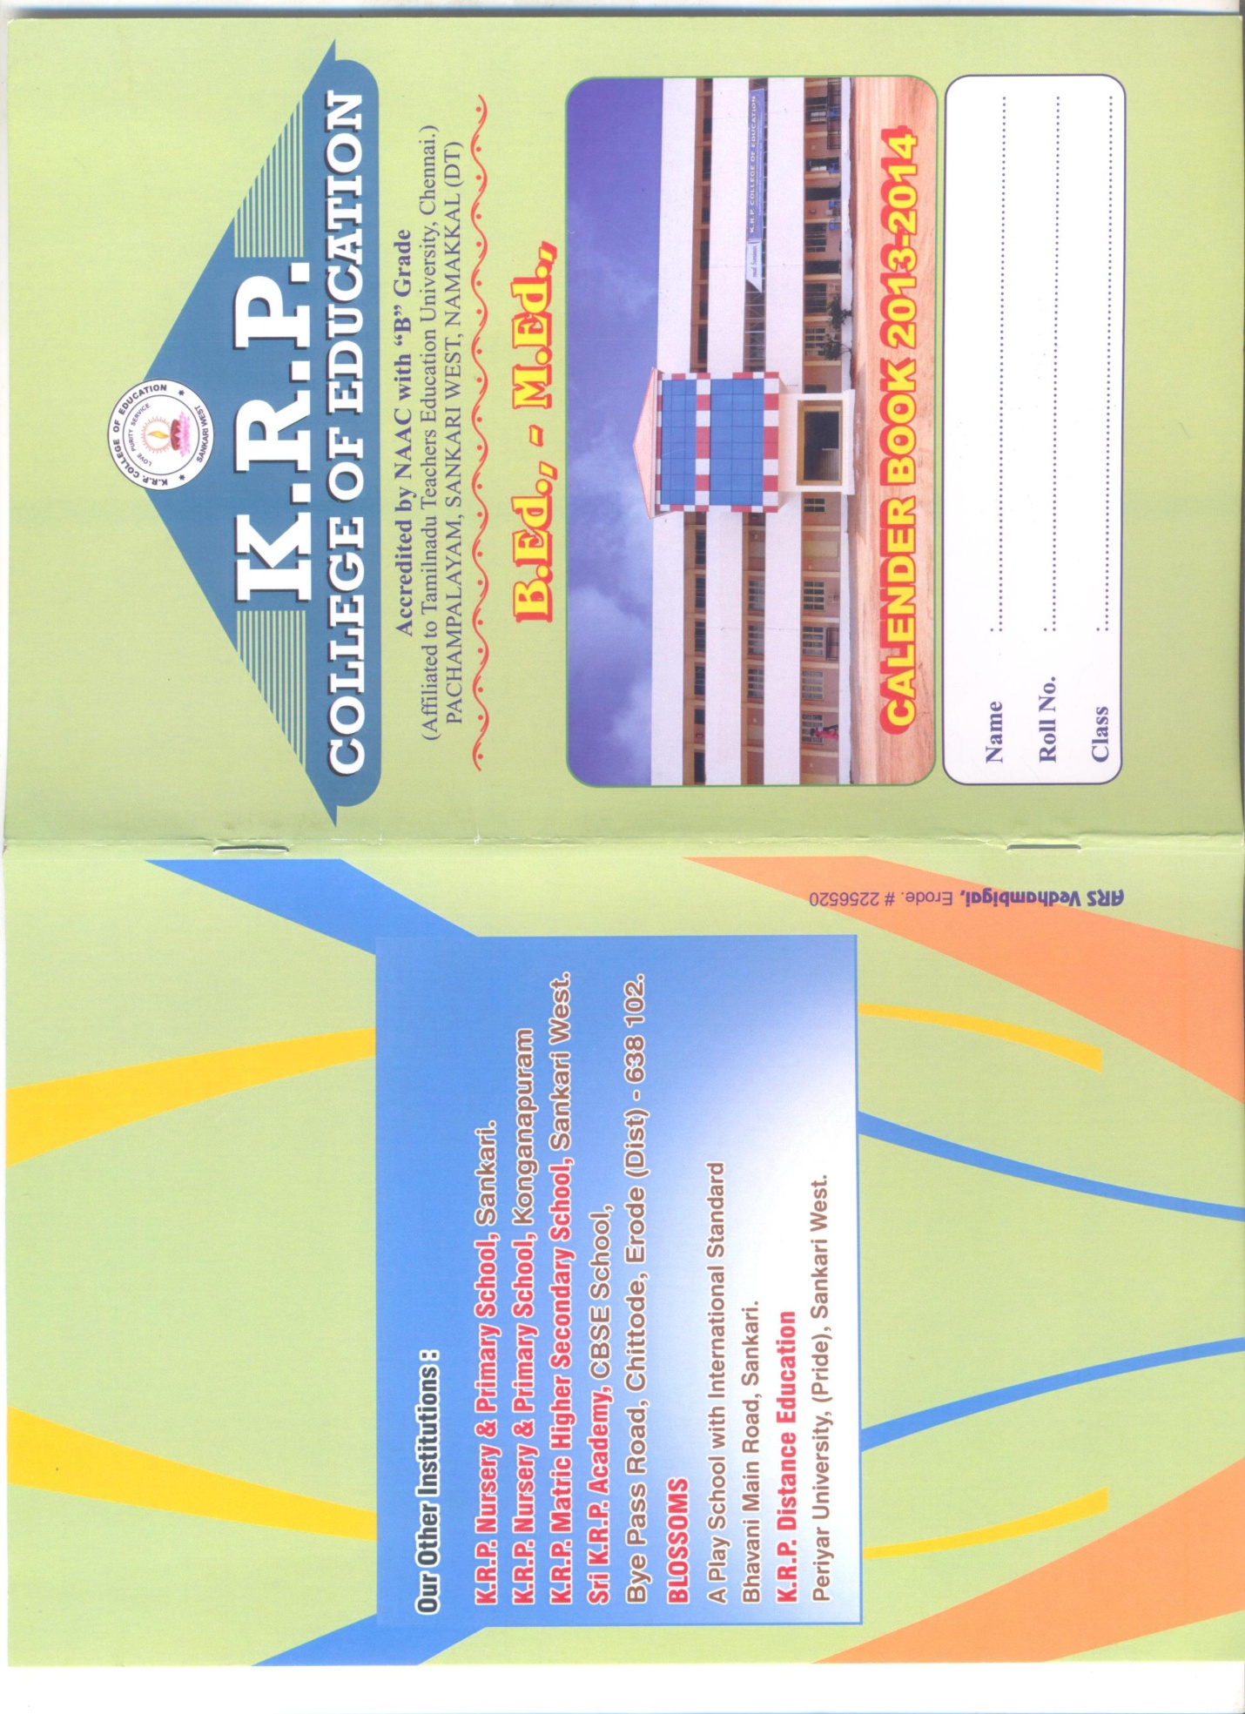

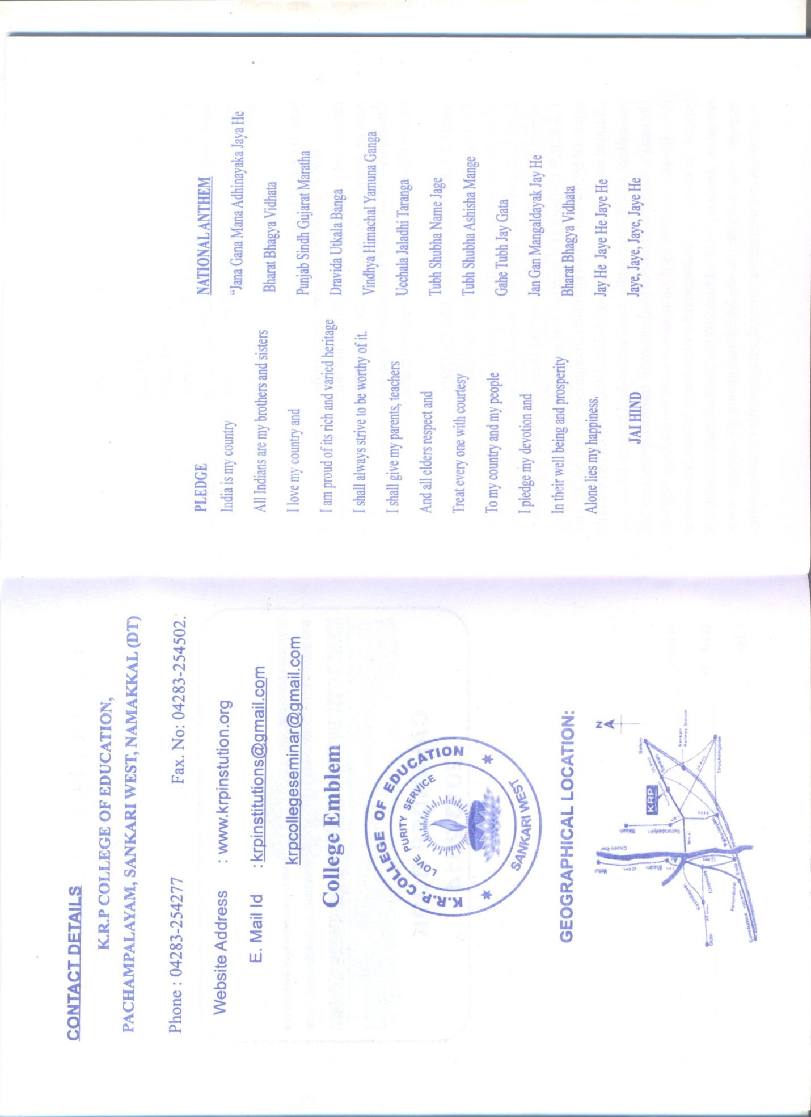
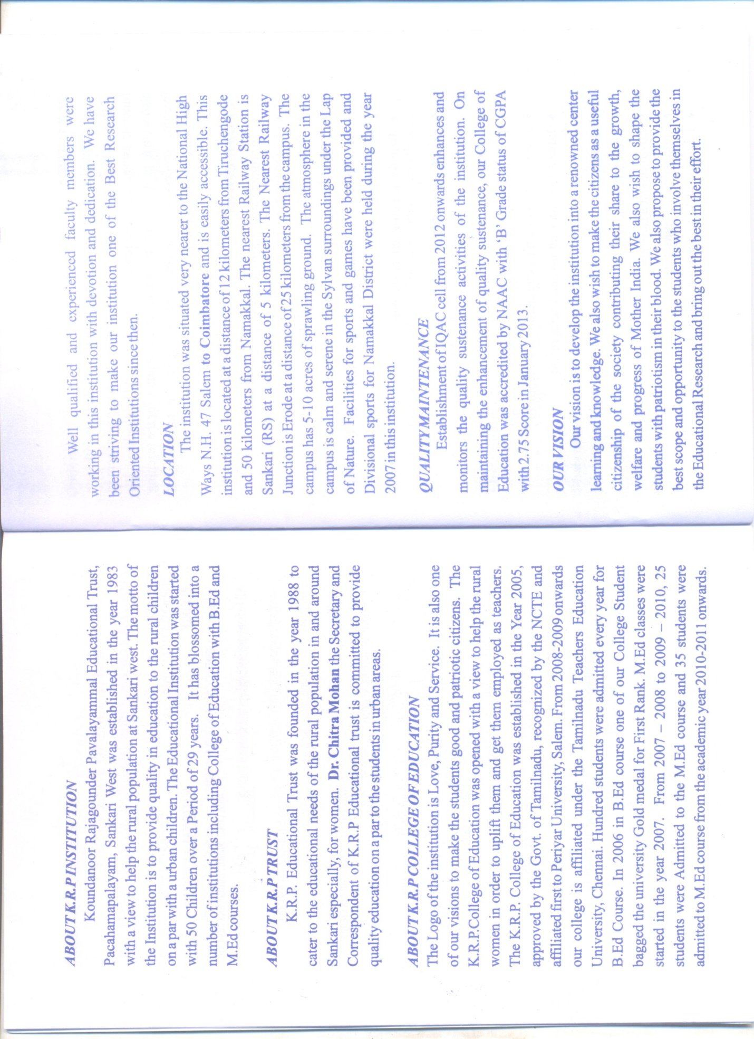
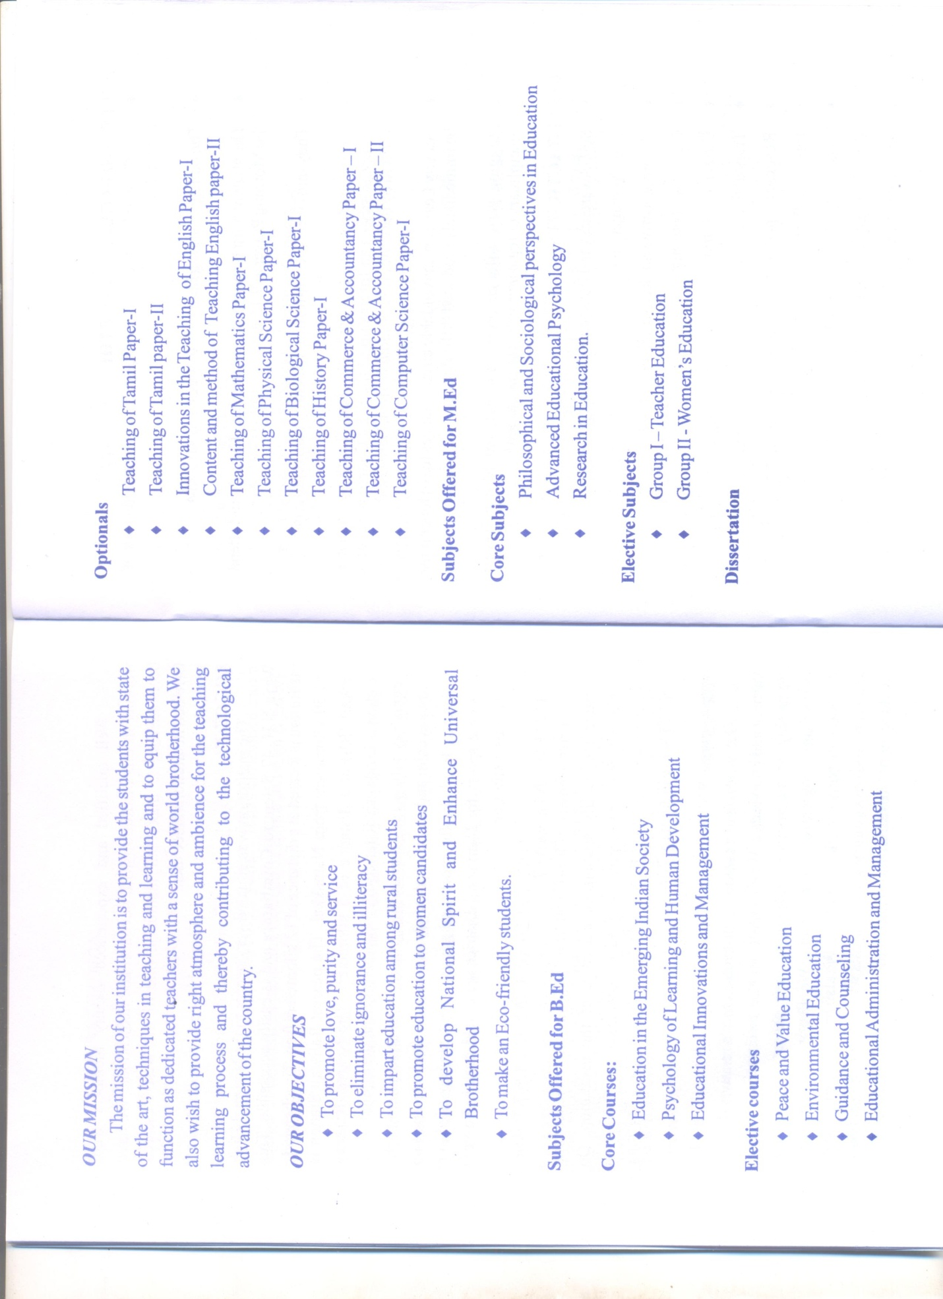
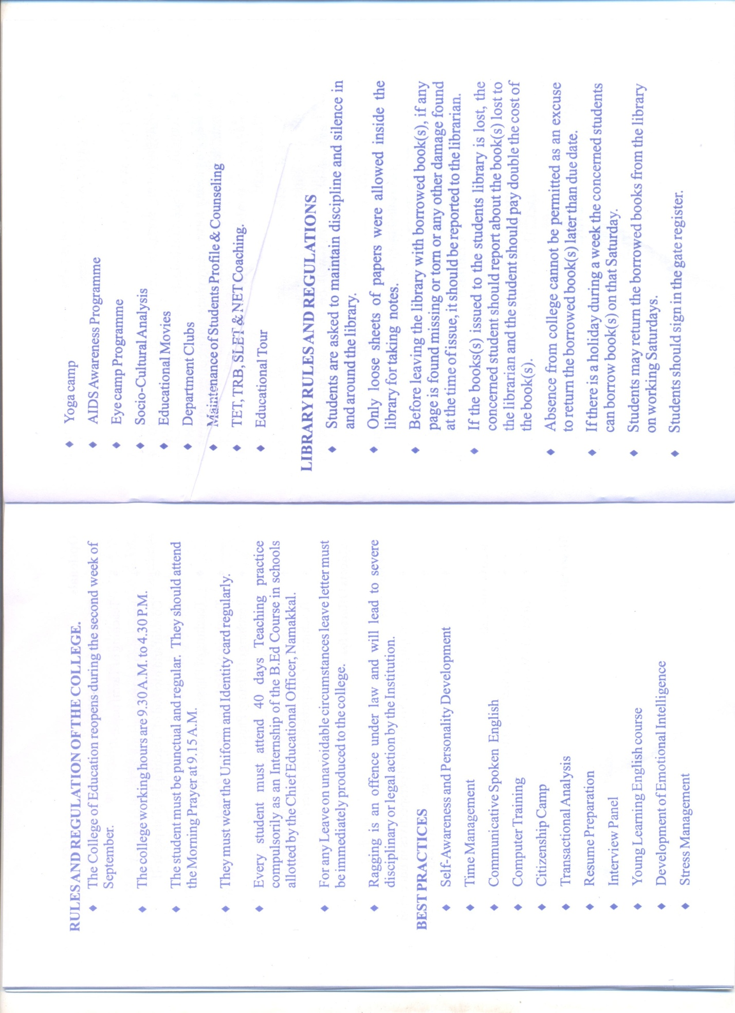
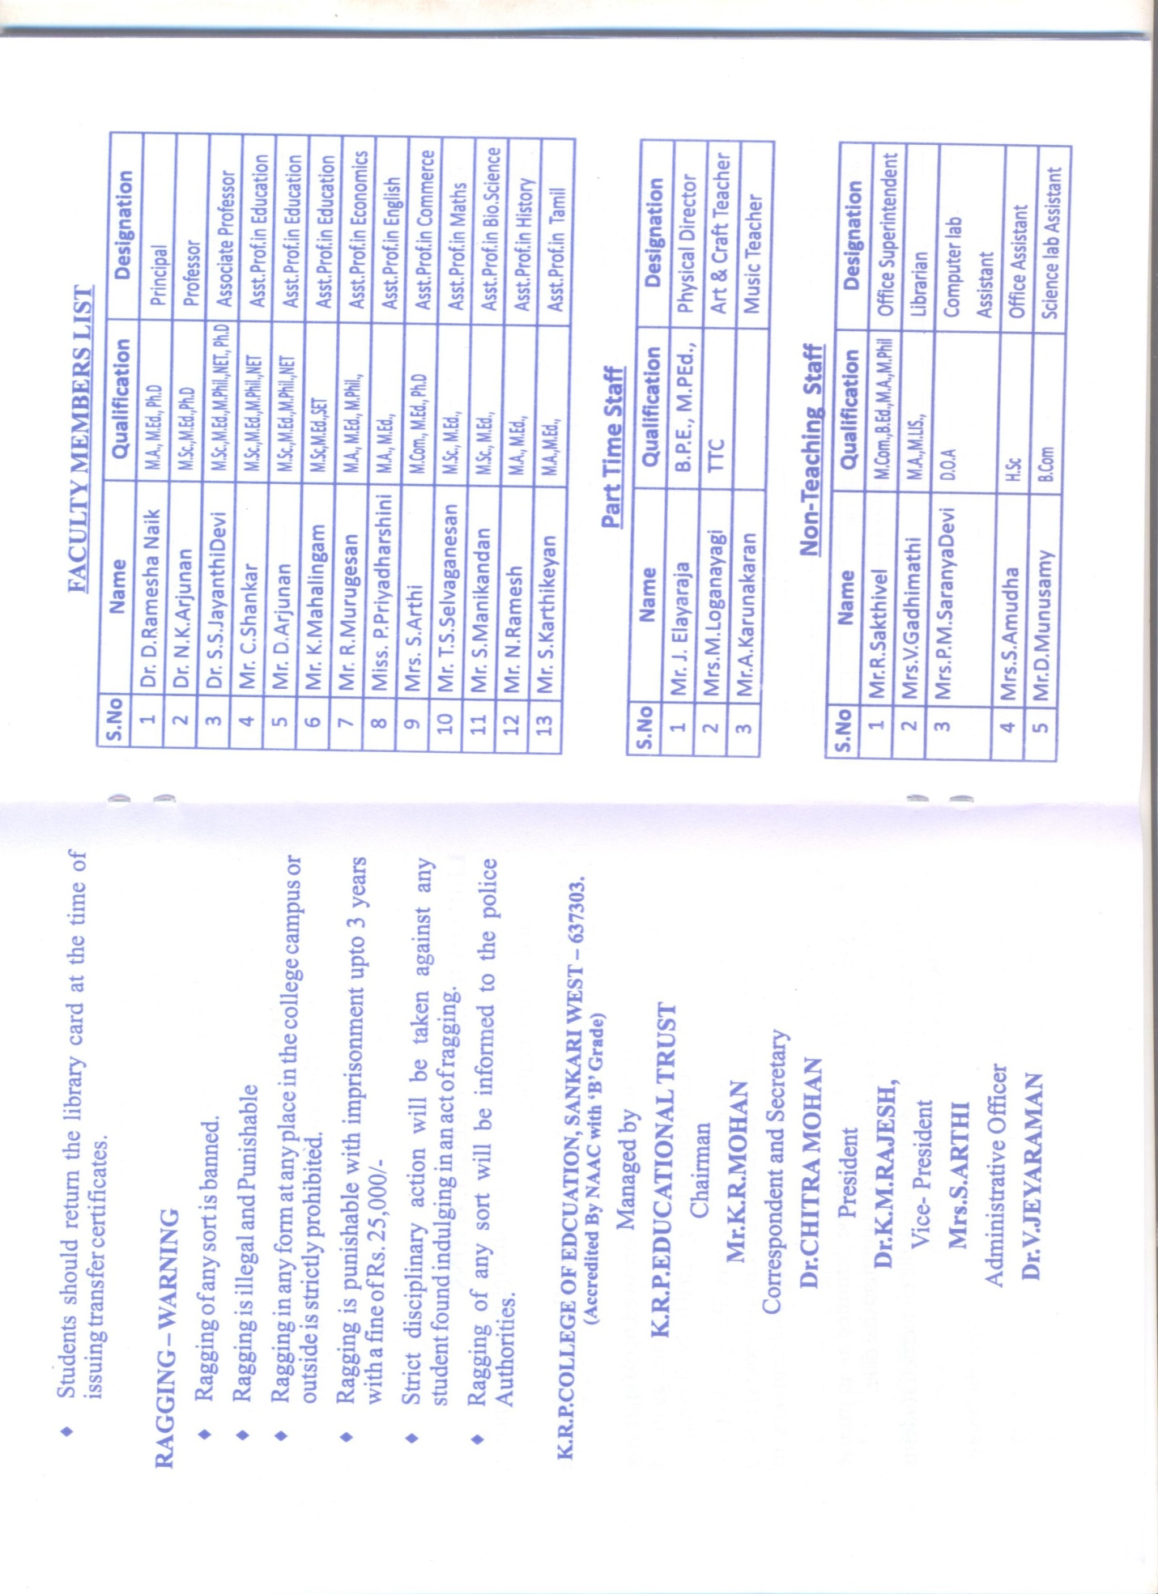
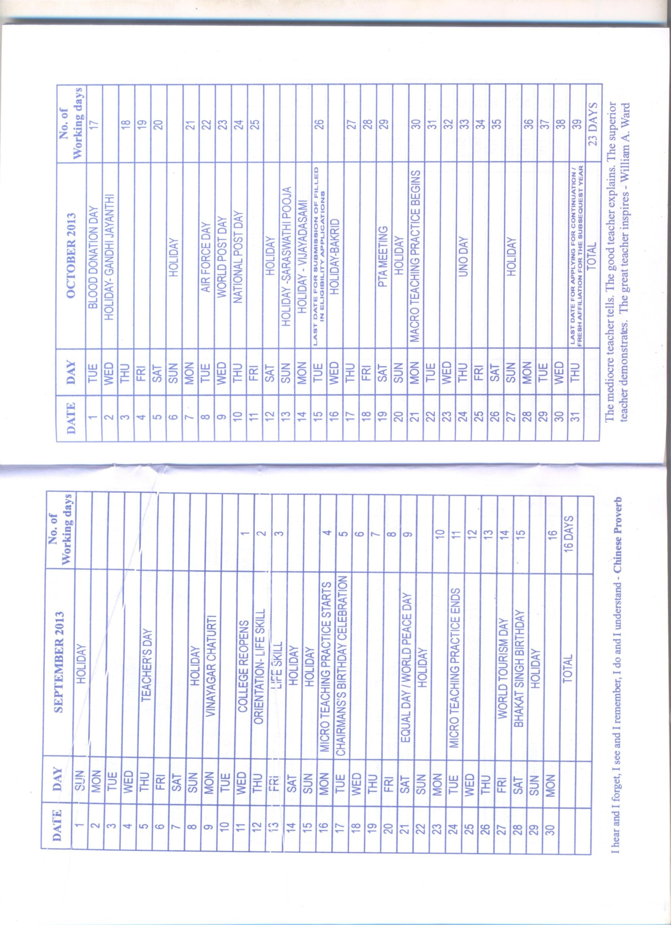
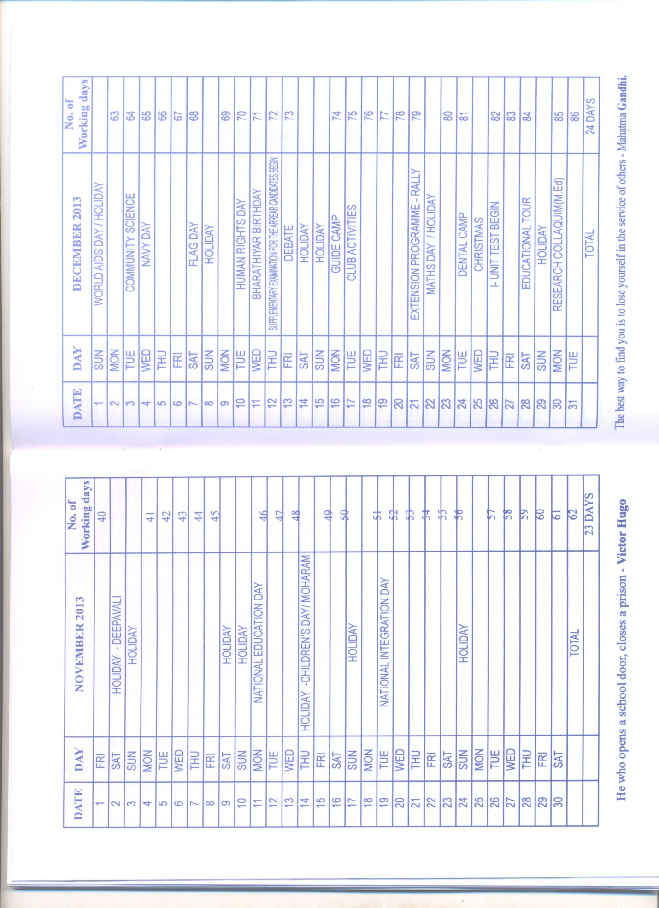
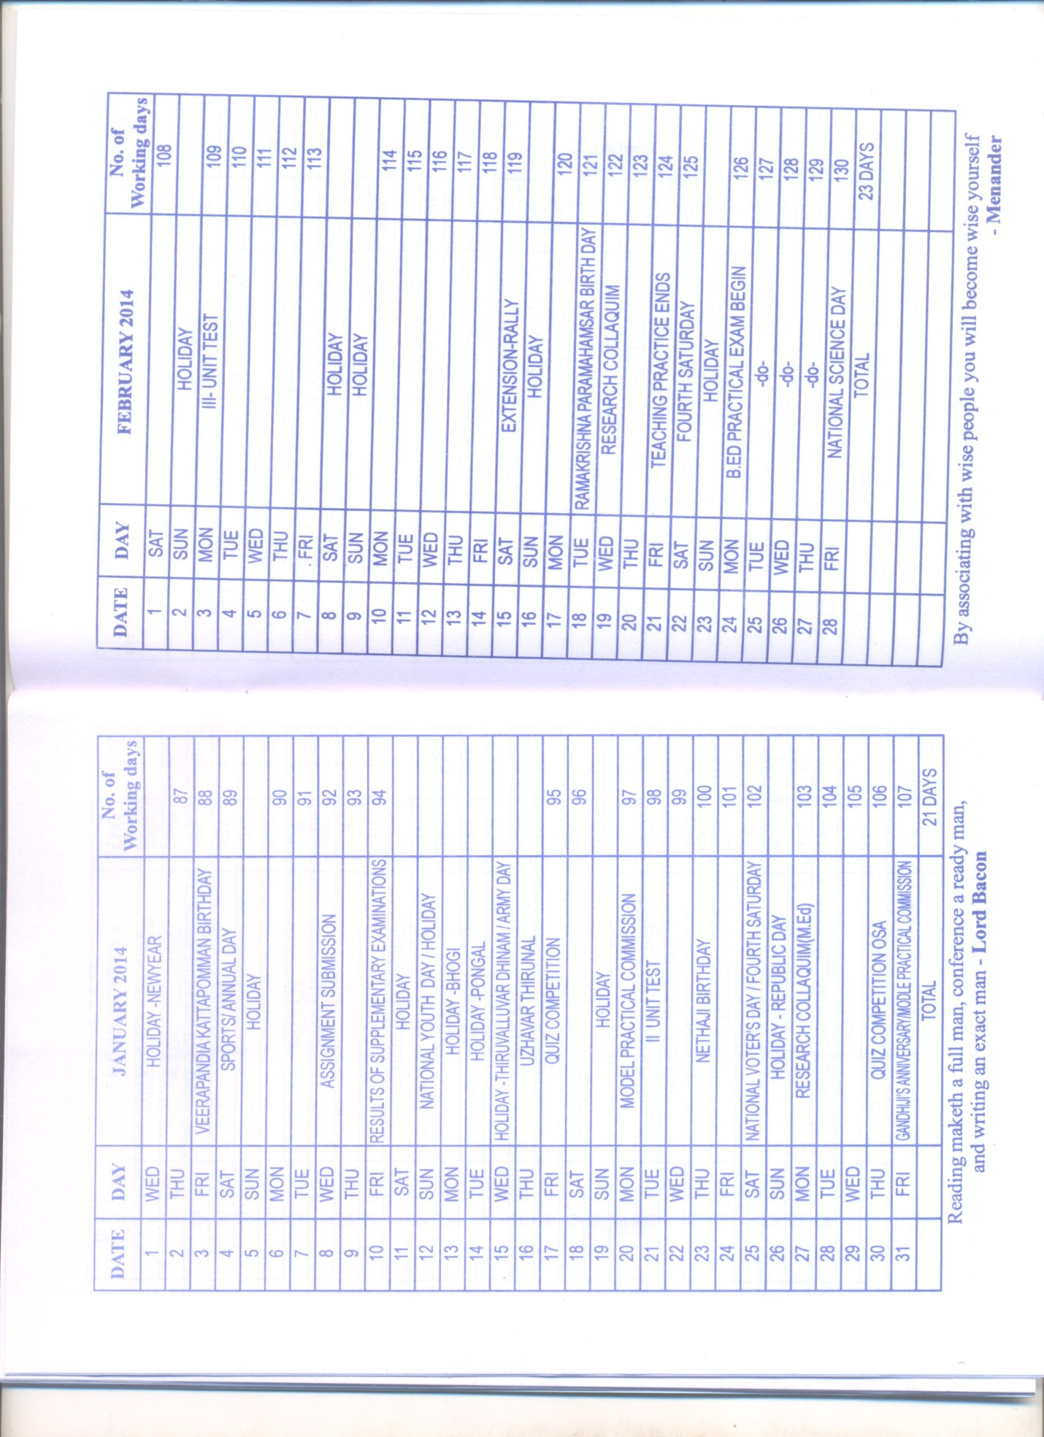
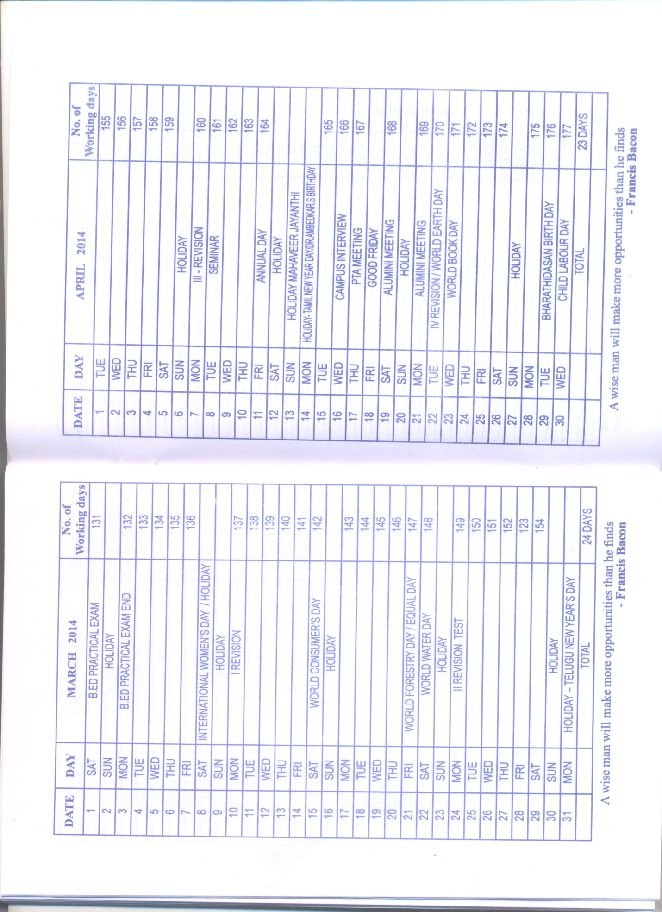
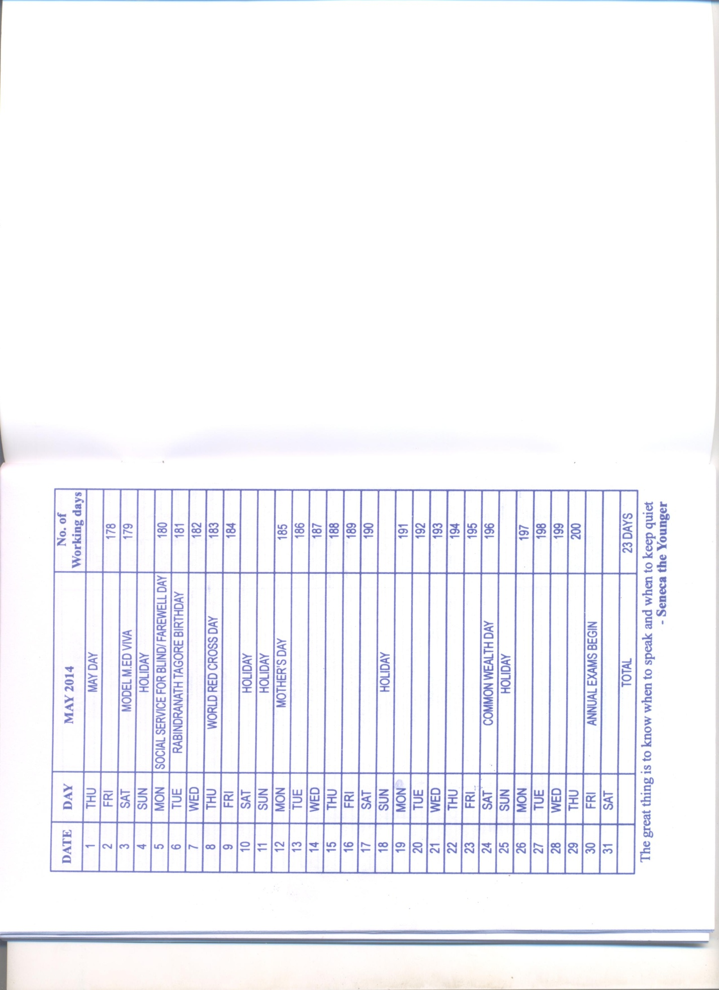

Annexure II

An Analysis of the feedback by various stake holders –Annexure-II

In the alumni association, they appreciated the students’ active participation in co-curricular and intercollegiate cultural & sports competitions. They also expressed their views regarding organization of the National seminar conducted by the college. Some of them appreciated for implementing the soft skills which will improve communication skills.
The students’ feedback was obtained for all the faculties in the B.Ed course. The students appreciated the efforts taken by the teachers in providing communication skill, learning materials and in discussing the topics. The students also appreciated the lecturers for maintaining a good rapport with them and providing notes for the salient features of the required topics.

Annexure III

OUR VISION

“Our College aims at the integral formation of Prospective teachers

to empower student-teachers

to become Responsible citizens and

agents of social transformation”
Our vision is to develop the institution into a renowned center for learning and for gaining knowledge. We also wish to make the B.Ed Trainees to be a good useful citizen of the society contributing to the growth, welfare, and progress of Mother India. We also wish to shape the students with patriotism in their blood. We also propose to provide the best scope and opportunity to the students who involve themselves in the educational research and bring out the best in their effort.

OUR MISSION
The mission of our institution is to provide the students with the state of art, techniques in teaching and learning and to equip them to function as dedicated teachers with a sense of world brotherhood. We also wish to provide right atmosphere and ambience for the teaching learning process and thereby contributing to the technological advancement of the country.

OUR OBJECTIVES
- To promote love, purity and service
- To eliminate ignorance and illiteracy
- To impart education among rural students
- To develop National spirit and Enhance universal brother hood
- To make Eco-friendly students.
- To develop Internal Quality Assurance Cell (IQAC)
- To strengthen the research and development cell

Annexure IV-A
Annexure – IV (A)
Best Practices [K.R.P.College of Education]
1]. PEER TEAM TUTORING
Goal
To develop an action plan for the academic year 2014-2015. To make the students studying in B.Ed Course as tutors among their peer groups to teach by using the technology.
The context
Even though the B.Ed Students underwent 40 days Teaching Practice as well as Micro Teaching practice during their course, the peer team tutor is the one where a student forms a group of 10 Members and take class for a lesson using teaching aids and LCD Projector, there is chance for all individuals to take the class in a cycle. It provides a platform for the students to change the style of teaching and methodology as well as to learn more concepts not only from the textbook as well as from their team members which motivated them to learn and to gather informations up-to-date.
The practice
- The students were announced by the staff members regarding the peer team tutor.
- Students in the beginning hesitated to come forward. But when a single group activated this programme successfully, automatically the other peer group members motivated to do it actively.
- More over Ten Peer Team groups were formed and they were given instructions by the teaching faculties how to take class.
- Efforts were made to arrange the classrooms along with the LCD Projector to take the class.
Evidence of success
All the students enthusiastically participated in this and they took it as a challenge and it became as who is a best tutor among their groups. The students were encouraged to take class in future like this.

Problems encountered by the teacher trainees

When the students were informed regarding this no student got up and came forward. But when a teaching faculty explained this with a few students and when demonstrated, only two groups came forward. After one week, all the students came forward to conduct this programme successfully and they showed their innovative and creativeness in handling the classes as well as in gathering informations up-to-date.

Annexure IV-B

Annexure – IV (B)
Best Practices [K.R.P.College of Education]
2].EXTENSION PROGRAMME – STUDENTS PROJECT
Goal
To encourage the students to participate in the youth science festival. To make the students to undertake a mini research project.
The context
B.Ed students were informed about the youth festival 2015 and were motivated to participate in that festival and to present a research paper. This festival was organized by Tamilnadu Science Forum, hosted by B.S.Abdur Rahman University. This provides a platform for invention and innovation by the young minds in the use of science for the betterment of society and the growth of our nation and organizing for a scientific egalatirarian society. It is based on the exploration of everyday life situations which provides a cooperative among the team members.
The practice
Four of our B.Ed students came forward enthusiastically to participate in this and showed their interest to do this research successfully. One of our teaching faculty has been appointed as a guide to motivate and guide the students to complete their work systematically and successfully.
The guide and his team took effort in doing this project.
- They selected the topic first which is entitled as ‘Environmental Awareness among House Wives”.
- A questionnaire has been prepared and the data was collected by the team members in and around their residential area.
- After the data collection, the obtained scores were analyzed and interpreted by using descriptive and inferential statistics.
- From the study it was revealed that the rural literate house wives have more awareness regarding the environment than the urban illiterate house wives.
- House wives whose age are below 25 are having more social communication with others and have move awareness than the others

Evidence of success
After finishing the project successfully the students went to Chennai for presenting the paper on 14nth and 15nth of March 2015 and got the participation certificate. Our students were appreciated and congratulated for undertaking such projects.

Problems encountered and resources required
During the data collection, the students faced problems but when it was explained the house wives came forward in filling the questionnaire.

